# **ASSIGNMENT – 03**

Name: T . Jithendra

Register Number: **192111**521

Subject: Object Oriented Programming with C++

Subject Code: DSA0163

SINGLE INHERITANCE:

#include <iostream>

using namespace std;

class start

{

public:

int a;

void set()

{

cout<<"Enter the value of a: ";

cin>>a;

}

void display()

{

cout<<"A = "<<a<<"\n";

}

};

class final : public start

{

public:

int b;

void set1()

{

cout<<"Enter the value of b: ";

cin>>b;

}

void display1()

{

cout<<"C = A * B "<<a*b<<"\n";

}

};

int main()

{

final F;

F.set();

F.set1();

F.display1();

return 0;

}

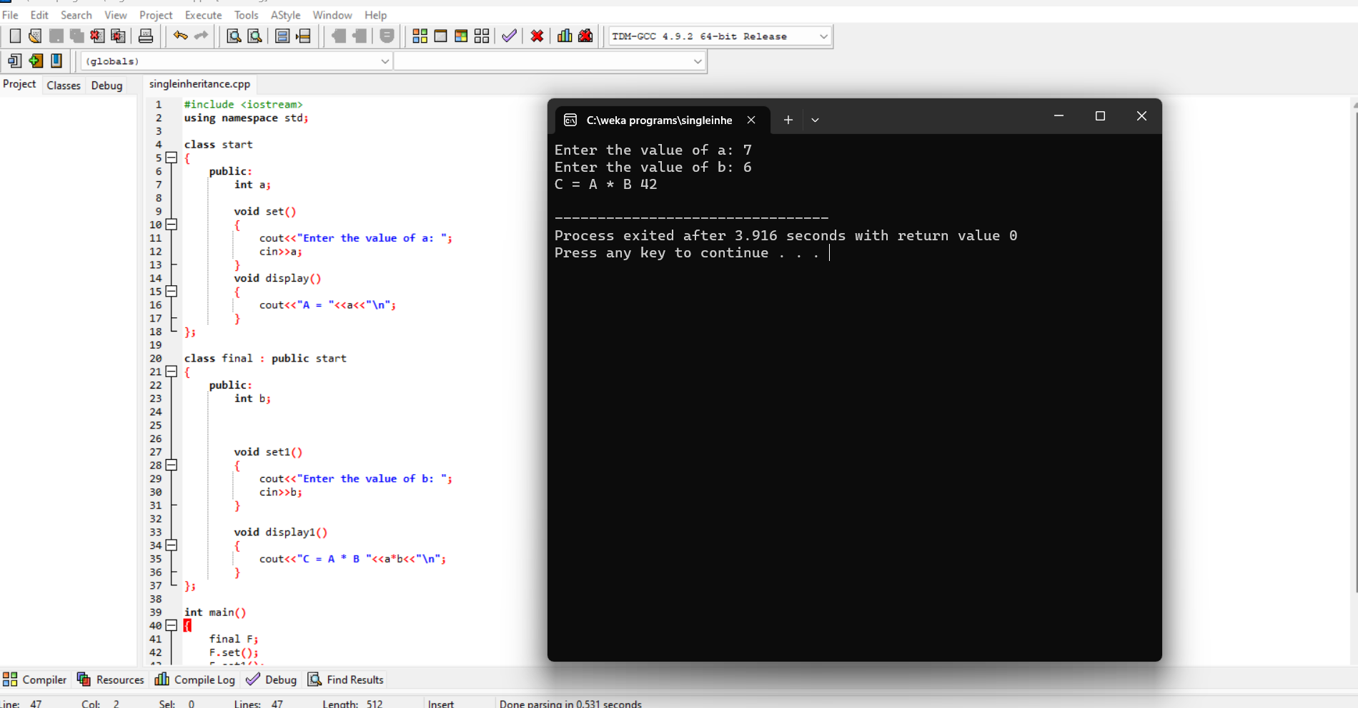

MULTIPLE INHERITANCE:

#include <iostream>

using namespace std;

class start

{

public:

int a;

void read()

{

cout<<"Enter the value of a: ";

cin>>a;

}

void display()

{

cout<<"A ="<<a<<"\n";

}

};

class middle

{

public:

int b;

void read1()

{

cout<<"Enter the value of b: ";

cin>>b;

}

void display1()

{

cout<<"B ="<<b<<"\n";

}

};

class finish : public start , public middle

{

public:

int c;

void read2()

{

cout<<"Enter the value of c: ";

cin>>c;

}

void display2()

{

Cout<<"Multiplication:" <<a*b*c<<"\n";

}

};

int main()

{

finish F;

F.read();

F.read1();

F.read2();

F.display2();

}

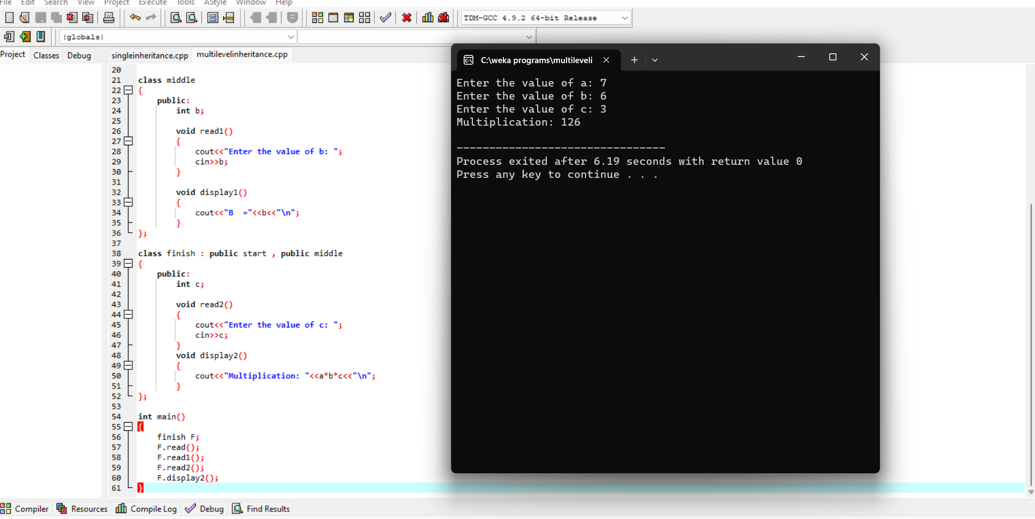

MULTILEVEL INHERITANCE:

#include <iostream>

using namespace std;

class start

{

public:

int c;

void read()

{

cout<<"Enter the value of c: \n";

cin>>c;

}

void display()

{

cout<<"C ="<<c<<"\n";

}

};

class middle : public start

{

public:

int b;

void read1()

{

cout<<"Enter the value of b: \n";

cin>>b;

}

void display1()

{

cout<<"B ="<<b<<"\n";

}

};

class final : public middle

{

public:

int a;

void read2()

{

cout<<"Enter the value of a: \n";

cin>>a;

}

void display2()

{

cout<<c+b+a;

}

};

int main()

{

final F;

F.read();

F.read1();

F.read2();

F.display2();

}

